Practical-8
Aim:
Problem 1
A company stores its organizational hierarchy as a tree — the CEO at the top, managers below,
and employees at the leaves. Different departments need the hierarchy printed in different
orders: HR wants each manager printed between their left and right sub-teams, the archive
department wants each manager printed before their sub-teams, the payroll department wants
each manager printed after all their sub-teams are listed, and the floor manager wants everyone
printed level by level from top to bottom. Given a binary tree representing the hierarchy,
implement all four printing orders and display the result of each.
Describe how your solution for level-by-level printing differs from the other three. What
additional structure did you need to use, and why does the same recursive approach that works
for the other three not directly apply here?
Problem 2
A school library uses a system where every book is assigned a unique code when it arrives.
Books are organized so that at any shelf position, all books to the left have smaller codes and
all books to the right have larger codes. This arrangement lets staff find any book quickly by
always knowing which direction to look. Given a sequence of book codes arriving one by one,
insert each into the correct position and print the inorder sequence after all insertions are
complete.
Describe how your solution decides where to place each new book code. What property of the
final inorder sequence tells you whether all insertions were performed correctly?

Practical-Link:
https://github.com/kahanipatel156-dev/FDSA-Batch-B/upload/main/Practical-8

Screenshots:
Problem 1:
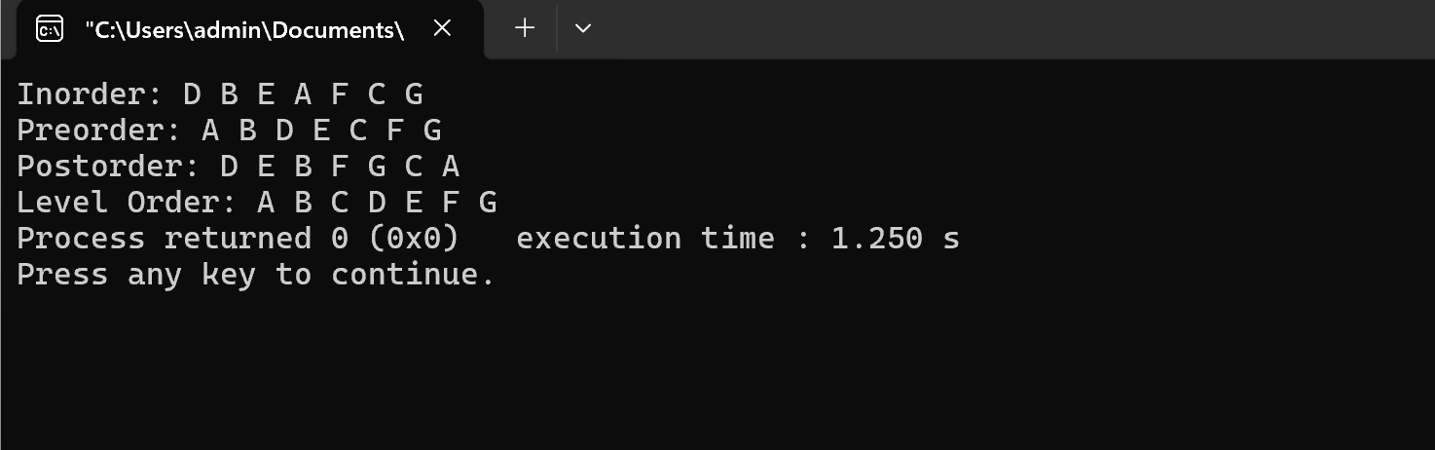
Problem 2:

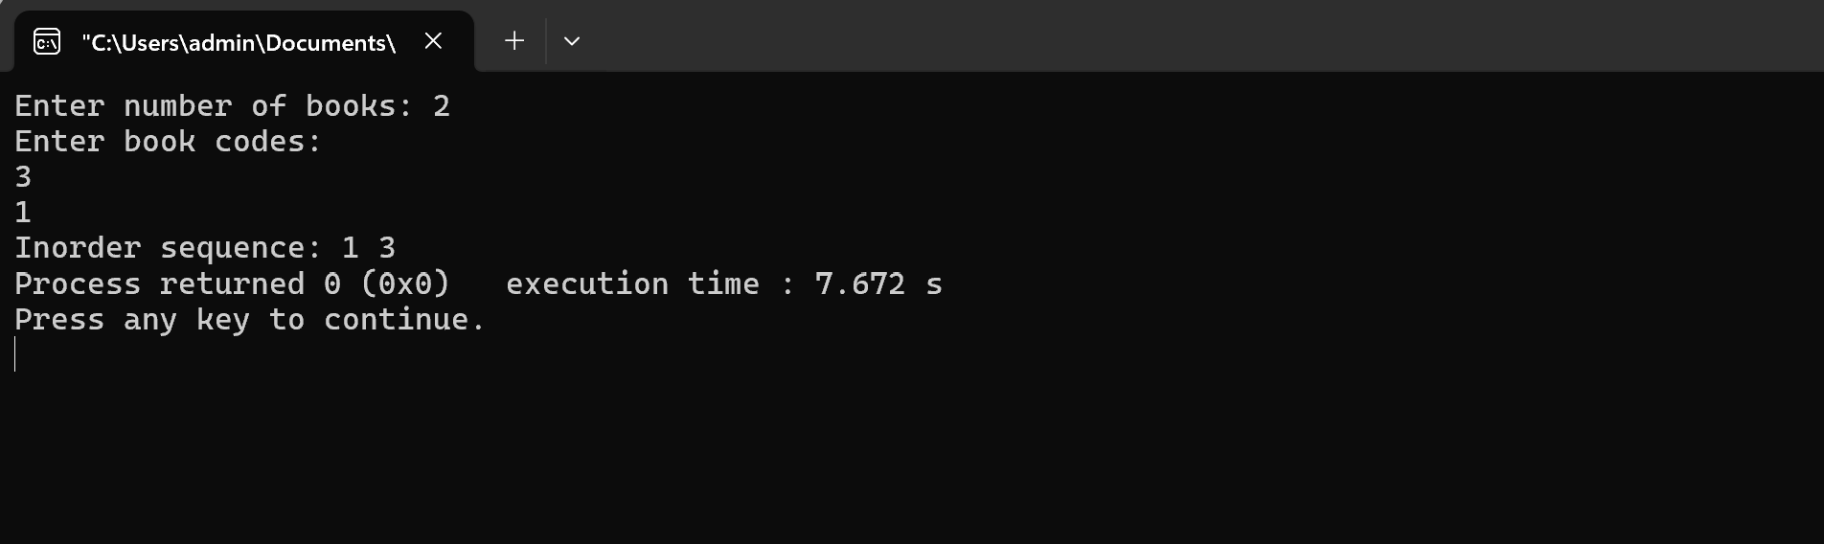

Problem faced:
Understanding and implementation of concepts.
Learning:
Implementation of binary trees.

